**TEAM 4 - SCIENTIFIC CALCULATOR**

**PROJECT REPORT**

**TEAM ASSOCIATES**-

SAI KEERTHI

R SANJANA

ANUSHA V C

AISWARIYA S

ANURAG

VINAY HP

KURASALA SAI ANUSHA

SHAIK REHANA

MIDHUN M MENON

TABLE OF CONTENTS

|  |  |  |
| --- | --- | --- |
| 1 | ABSTRACT |  |
| 2 | REQUIREMENTS |  |
| 3 | RESEARCH |  |
| 4 | SWOT analysis |  |
| 5 | Detail Requirements |  |
| 6 | Design |  |
| 7 | Test Plan |  |
|  |  |  |

**ABSTRACT**

The advanced scientific calculator performs various operations ranging from calculating the sum, difference, product, division,bitwise Or, bitwise and, xor of two numbers to calculating the factorial, power ,square ,cube ,sine,cosine,tan,abs,exponent and logarithm of a given number.

**REQUIREMENTS**

SOFTWARE REQUIREMENTS

* Ubuntu 20.04
* Github desktop
* Visual studio code

**RESEARCH**

COST AND AGE

The Calculator we know today was first invented in the 1960’s. The use of smartphones as a calculator began in the 1990's.

Several computing machines were made long before the arrival of digital calculators and smartphones. The abacus, for example, was used in the ancient Near East, Europe, Russia, and China long before the adoption of the written Hindu-Arabic numeral system.

The Hewlett-Packard 9100A is an early programming calculator, first appearing in 1968. HP called it a desktop calculator.

The hp-34 was Hewlett-Packard's first pocket calculator and the world’s first scientific pocket calculator. A calculator with Trigonometric & Exponential functions. It was introduced in 1972

The SR-50 was Texas instruments first scientific pocket calculator with Trigonometric & Logarithmic functions. It was introduced in 1974.

Casio is a major player in the graphing calculator market. It was introduced in 1985. Notable features are its ability to graph functions and that it is programmable.

Table:

|  |  |  |
| --- | --- | --- |
| Year | Model | Cost |
| 1972 | Texas TI 2500 | $149.95 |
| 1985 | Casio fx-7000G | $75 |
| 1988 | Texas TI-68 | $55 |
| 1992 | Texas TI-85 | $130 |
| 2020 | Texas TI-30XS | $18.13 |

**CONSOLIDATING FEATURES**

|  |  |
| --- | --- |
| Pros | Cons |
| Calculators can solve complicated problems in an efficient manner. | People will be so dependent on using it for counting. |
| It gives more accurate results. | Users will become ‘LAZY’ because of usage of calculators. |
| It has all the formulas for counting processes & makes the counting process easier. | Chances of lacking an individual's computational skills. |
| It reduces time complexity. | Relying too much on calculators for counting can embarrass the users. |
| Avoids the boredom in the counting process. | Trying out the operations without having proper knowledge of it. |
| It helps the users minimize the mathematical errors. | Chances of cheating are possible due to graphical calculators. |
|  |  |

|  |  |
| --- | --- |
| Simple Calculator | Scientific Calculator |
| It can perform basic operations like add, sub, div and mul. | It can perform all the functions including specialized ones like trigonometry, log and exponential. |
| It has a smaller sized screen only. | It has both a smaller sized and larger screen. |
| Here we cannot develop a graph for the function. | Graphs can be developed for the functions performed. |
| It is cost effective. | It is expensive comparatively. |

**DEFINING PRODUCT**

The advanced scientific calculator performs various operations ranging from calculating the sum, difference, product, division, bitwise or, bitwise and & xor of two numbers to calculating the factorial, power, square root, sine, cosine, tan, logarithmic values of a given number. It is equipped with a special feature to calculate the sum of all numbers till the given input number and also calculate the factorial of a given number.

**SWOT ANALYSIS**

|  |  |
| --- | --- |
| STRENGTHS   * User friendly * Efficiency | WEAKNESS   * Does not have more functions |
| OPPORTUNITIES   * Increased requirement in market place * Adaptation to develop the customer requirements | THREATS   * Increase in number of competitors |

**WHY:**

A machine is anything that reduces human effort. We use calculators so that we can find out answers to mathematical problems without using too much of our energy and time and also reducing our effort.

**WHAT:**

A calculator is a machine which allows people to do math operations more easily. For example, a normal calculator will add, subtract, multiply, and divide. Even our computer is a calculator. There are two types of electronic calculators, the simple one, with only the main functions of plus, minus, times and division, and sometimes a square root, and the scientific one, with many other functions too such as factorials, and cosine functions.

**WHERE:**

The calculator is used everywhere. Basically it can be used in accounts where there will be large mathematical operations.

**WHEN:**

The calculator can be used whenever we want to perform any large arithmetic operation.

**HOW:**

The main objective of the calculator is to perform the different types of operation efficiently without wasting time in this busy world.

**Requirement Analysis**

Ø High Level Requirements

· Any calculator needs to have the highest speed and accuracy.

· The system should be multifunctional.

· The System should be user friendly and compact.

· The smart calculator’s battery lifetime should be more.

· The precision value should be high.

Ø Low Level Requirements

· The speed of the calculator, it should give output within seconds.

· The system functions need to be specified and work properly.

· The precision of the calculator should be more.

· The functions take input and process the output within nanoseconds.

**Requirement Mapping-**

High level requirements-

|  |  |
| --- | --- |
| ID | Description |
| 1 | Special functions like factorial,exponential,power must be included in the calculator. |
| 2 | Trigonometric functions like sine,cos,tan must be included to carry out trigonometric operations. |
| 3 | Binary operators like bitwise and,or,xor for processing the binary operations. |
| 4 | Square root, cube root, power functions to carry out complex calculations. |
| 5 | Precision should be high and speed should be in picoseconds |
| 7 | The functions should be selected and should produce correct output. |

Low level requirements-

|  |  |
| --- | --- |
| ID | Description |
| 1 | Symbols like +,-,*,/ to carry out simple addition, subtraction,multiplication and division to operations. |
| 2 | Must accept numbers from 0 to 9. |
| 3 | Calculator must be included with different calculation switching modes. |

**DESIGN:**

**COMPONENT DIAGRAM**

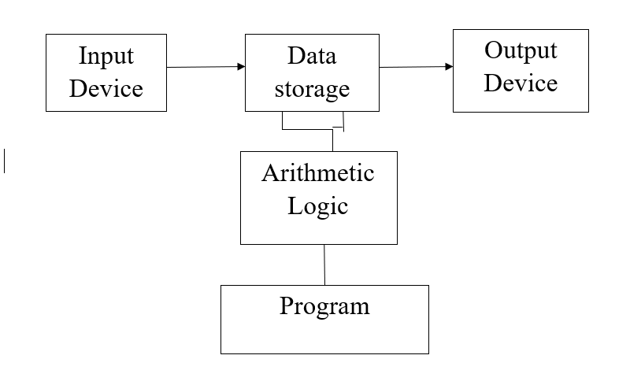

**USECASE DIAGRAM**

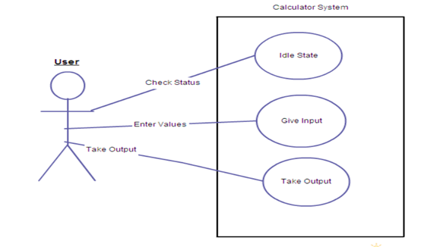

**UML DIAGRAM**

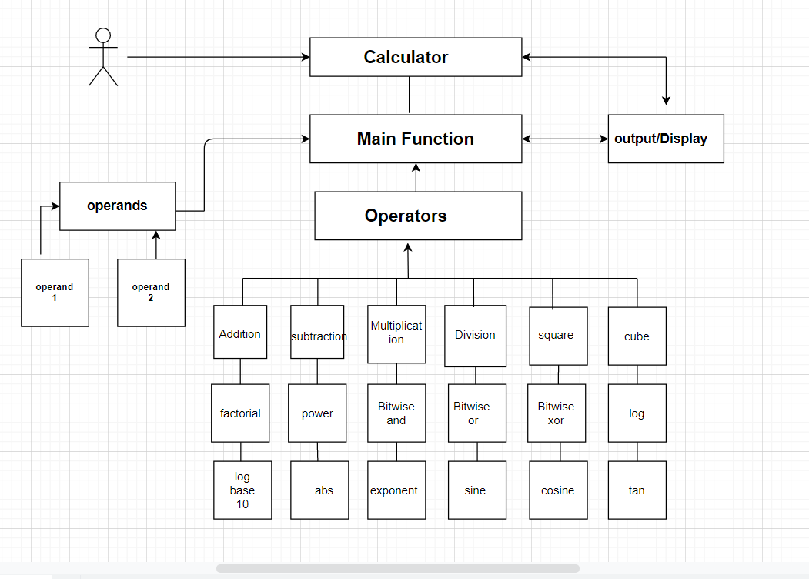

**ACTIVITY DIAGRAM**

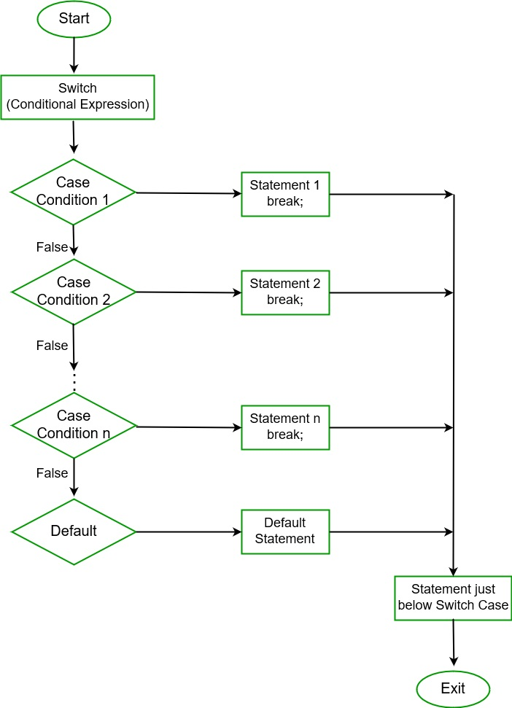

**LOW LEVEL UML DIAGRAMS:**

**ADD() & SUB()**

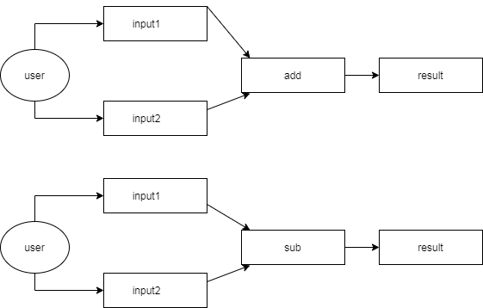

**MUL()**

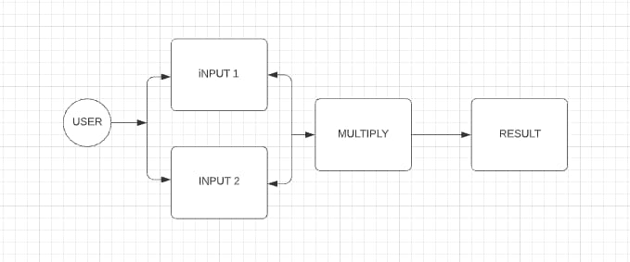

**DIV()**

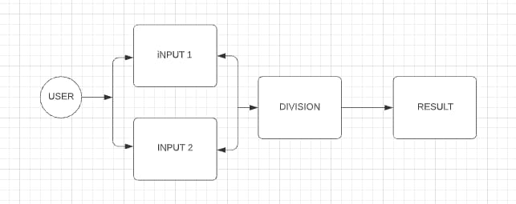

**SIN():**

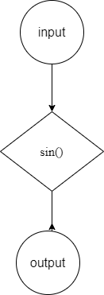

**COS():**

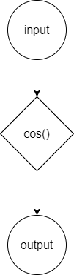

**TAN():**

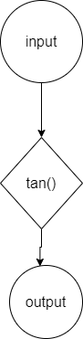

**FLOWCHART:**

**SIN():**

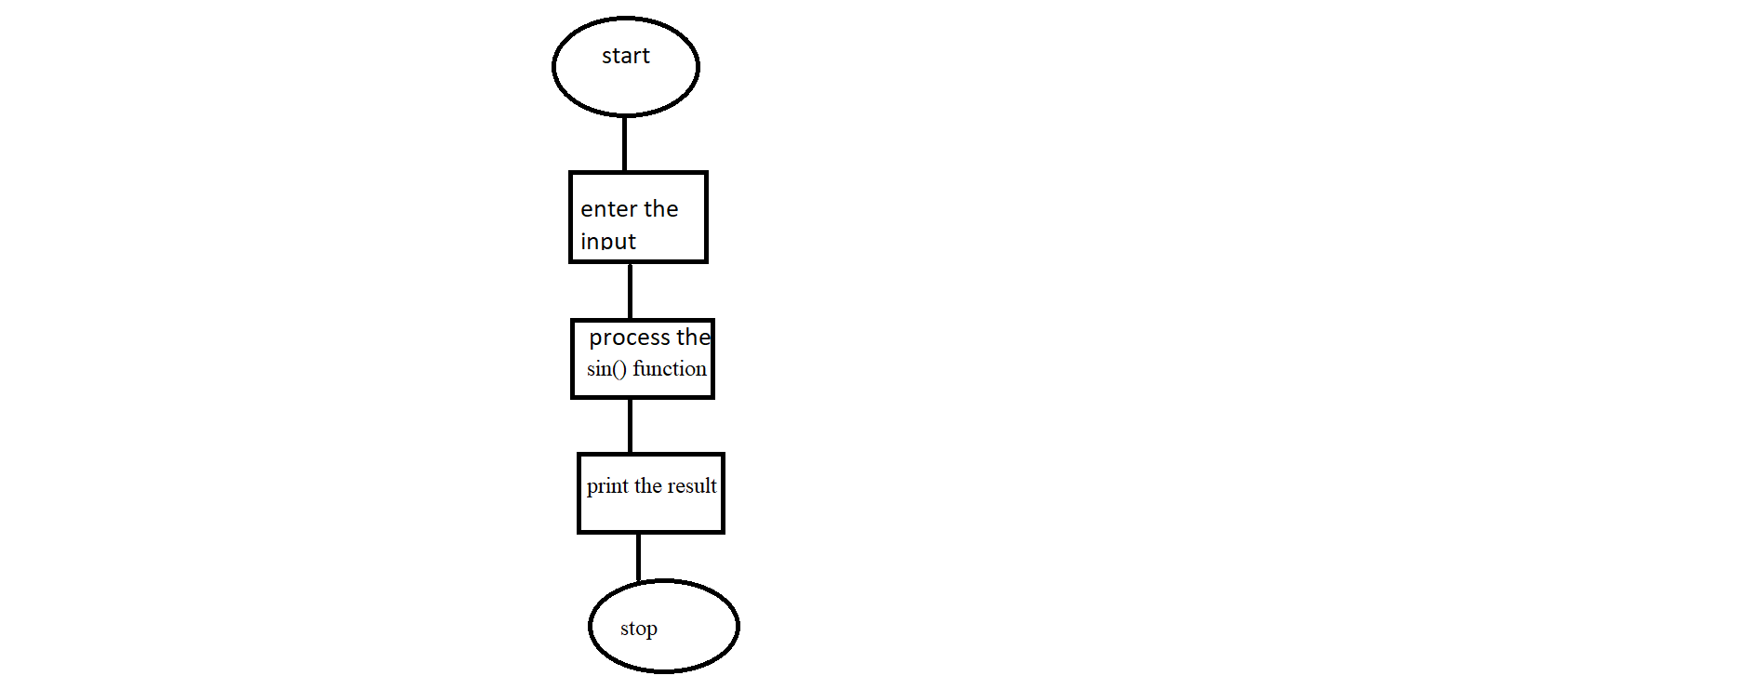

**COS():**

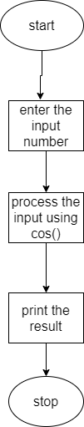

**TAN():**

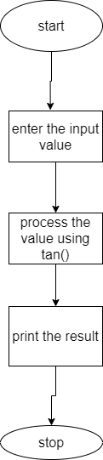

**POWER()**

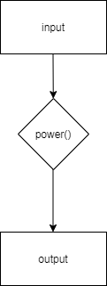

**Bitwise Xor**

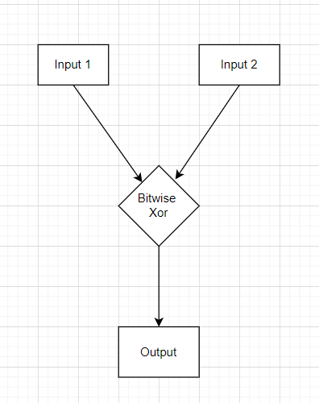

**Log Operation**

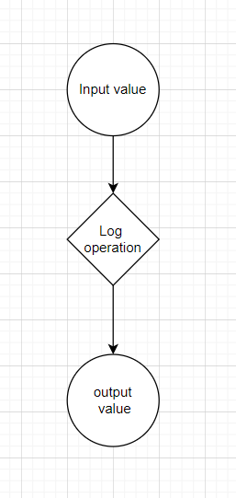

**Bitwise And flow chart:**

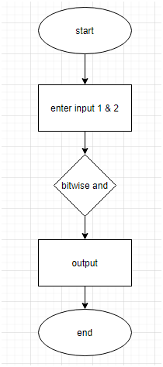

**UML Activity Diagram for Bitwise And:**

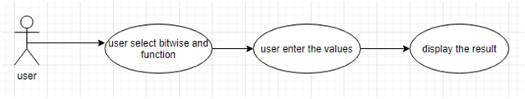

**Bitwise Or Flowchart:**

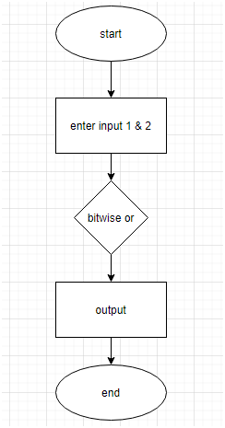

**UML Activity Diagram for Bitwise Or:**

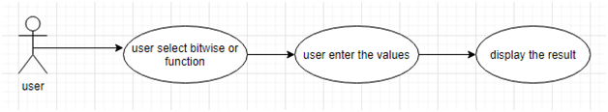

**EXPONENTIAL**

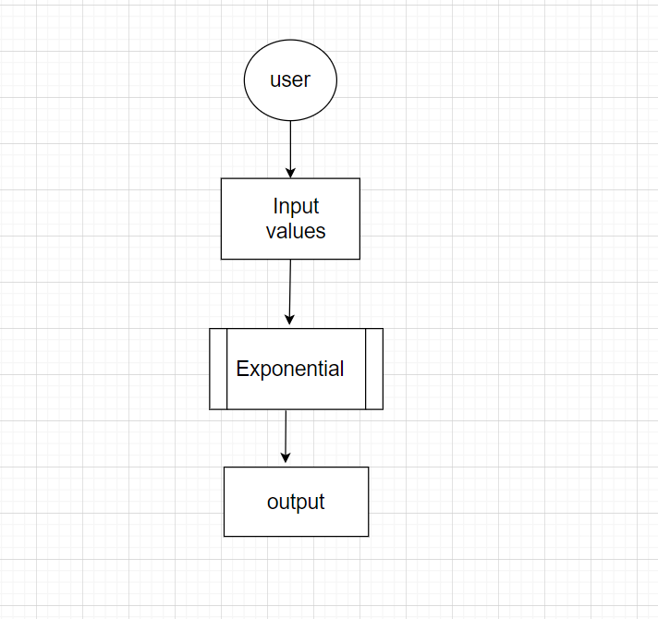

**LOG BASE 10**

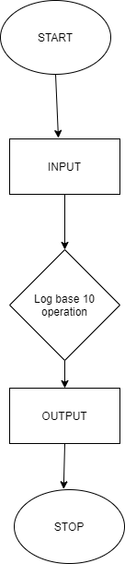

**Square Flow chart:**

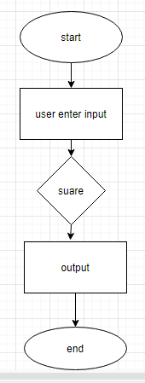



**Cube Flow Chart:**

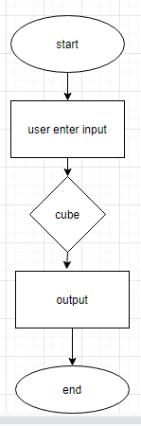

**CONVERSION FUNCTION TEST PLANS**

|  |  |  |  |
| --- | --- | --- | --- |
| ID | DESCRIPTION | EXPECTED INPUT | EXPECTED OUTPUT |
| TC1 | To add two float numbers and display the result on calculator | 2+2 | 4 |
| TC2 | To subtract two float numbers and display the result on calculator | 5-2 | 3 |
| TC3 | To multiply two float numbers and display the result on calculator | 2*3 | 6 |
| TC4 | To divide two float numbers and display the result on calculator | 50/2 | 25 |
| TC5 | To find square root of a number | Square root (16) | 4 |
| TC6 | To find cube root of a number | Cube root(27) | 3 |
| TC7 | To find factorial of a number | Fact(5) | 120 |
| TC8 | To find power of a number | Power of 2^3 | 8 |
| TC9 | To find bitwise-and of a number | 12 & 25 | 8 (Binary) |
| TC10 | To find bitwise-or of a number | 12 | 25 | 29 (Binary) |
| TC11 | To find bitwise-xor of a number | 12 ^ 25 | 21 (Binary) |
| TC12 | To find log of a number | Log (10) | 1 |
| TC13 | To find log base_10 of a number | Log base 10 of (11) | 1.041393 |
| TC14 | To find abs of a number | Abs(10) | 10 |
| TC15 | To find exponential of a number | Exp of (2) | 7.38905 |
| TC16 | To find sine of a number | Sin(90) | 1 |
| TC17 | To find cosine of a number | Cos(90) | 0 |
| TC18 | To find tangent of a number | Tan (45) | 1 |

**NORMAL TEST CASES IN CALCULATOR**

1. Check if the calculator is a normal calculator or a scientific calculator.

2. Verify that all the buttons are present and text written on them is readable.

3. Check the arithmetic operations are working fine- +, -, /, * etc.

4. Verify that the calculator gives the correct result in case of operations containing decimal numbers.

5. Check if the calculator is battery operated or works on solar power.

6. Verify the outer body material of the calculator.

7. Verify the spacing between the two buttons, the buttons should not be too closely placed.

8. Check the pressure required to press a button, the pressure required should not be too high.

9. Verify the number of digits allowed to enter in the calculator for any operation.

10. Verify the working of the ON-OFF button in the calculator.

11. Check if keeping the calculator unused for a certain period of time, turns it off automatically.

12. Verify the state of the calculator when two buttons are pressed simultaneously.

13. Verify if the user can delete digits one by one using the backspace key.